**Virtual Machines (Resizing)**

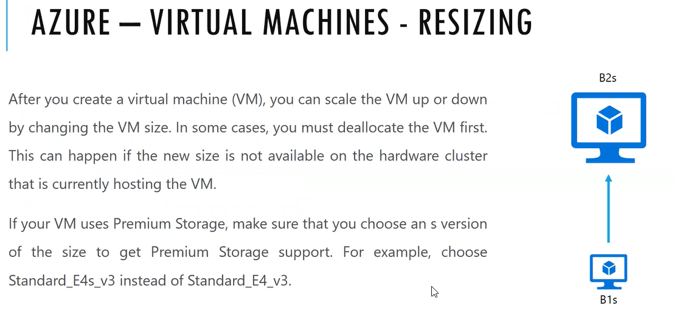

with out knowledge or wrongly during deployment we have assigned the disk to low size.

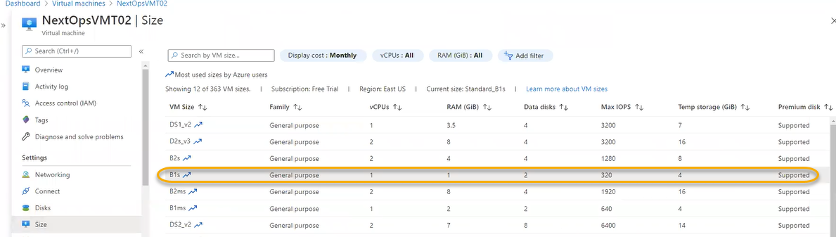

B1s is the low size we assigned to the VM due to that we may see resource impact or performance impact internally

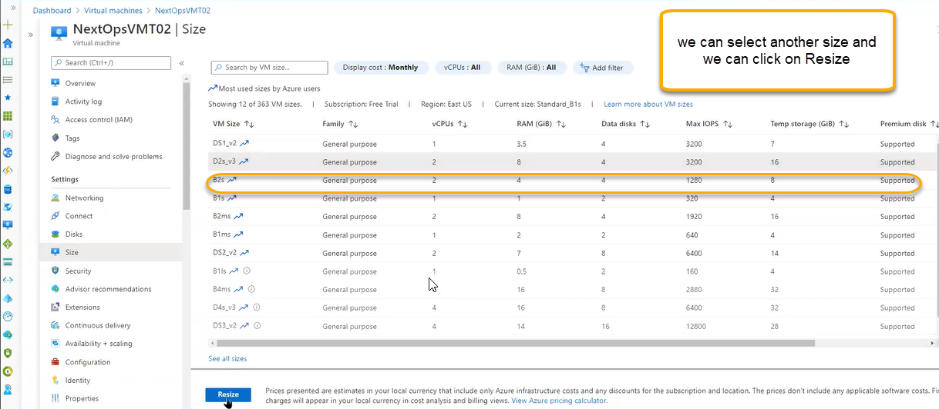

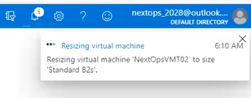

For doing this operation virtual machine must be power off state/ deallocated state

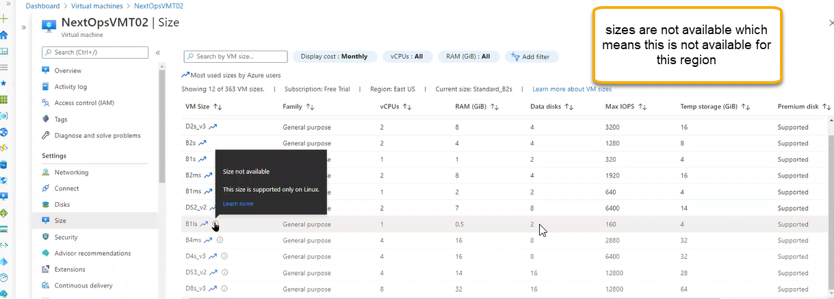

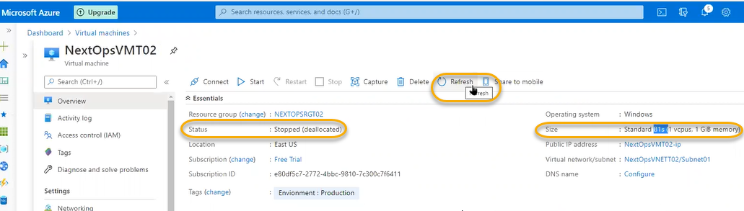

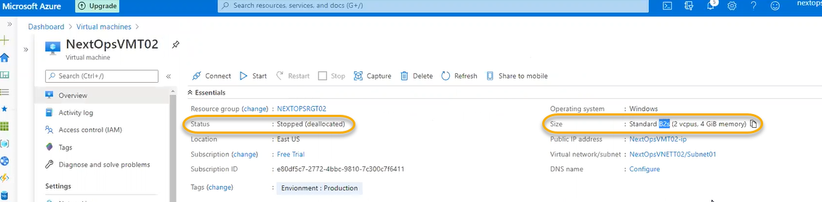

Security

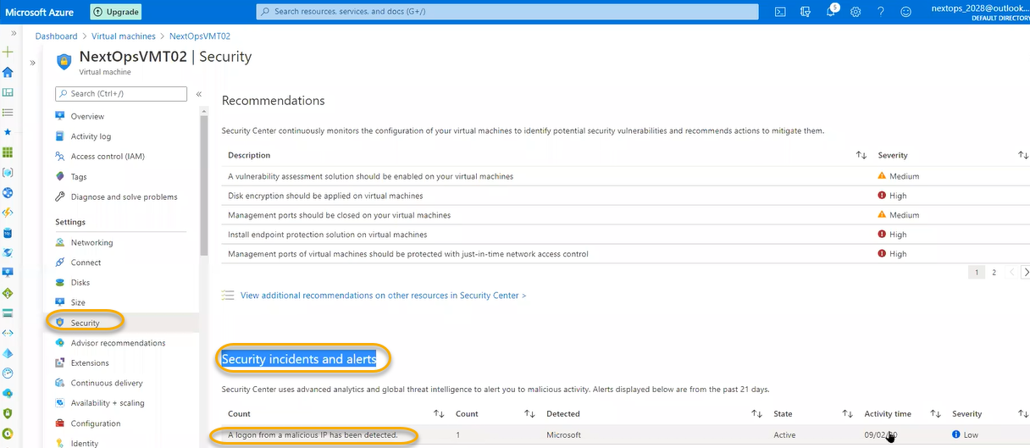

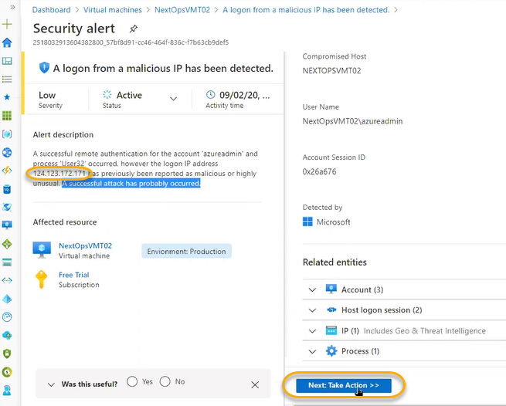

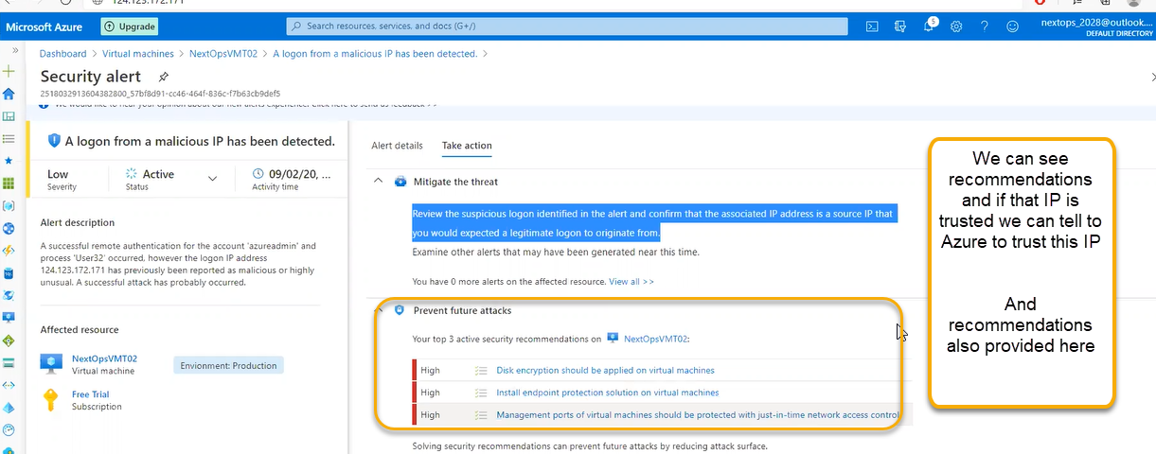

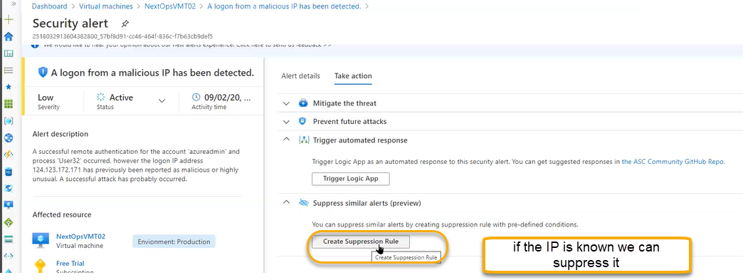

Advisor recommendations

For VM/Resource if misuse happening regarding to budget, performance point of view or if you select the size and you’re not utilizing that size or selected size is not sufficient upgrade to next size

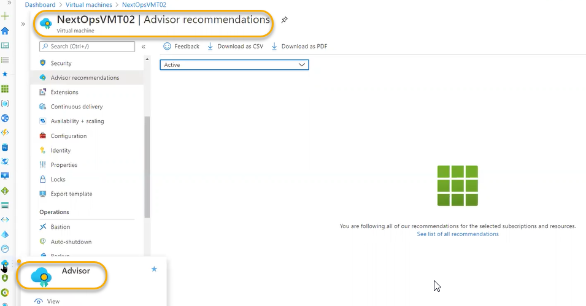

Advisor is for over all subscription recommendations

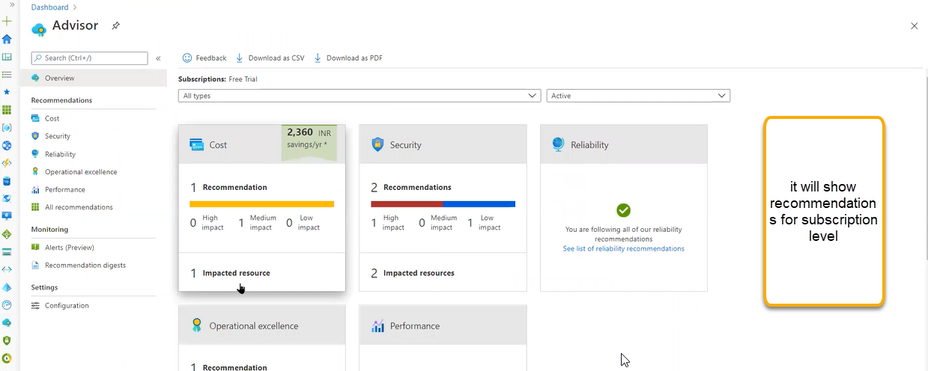

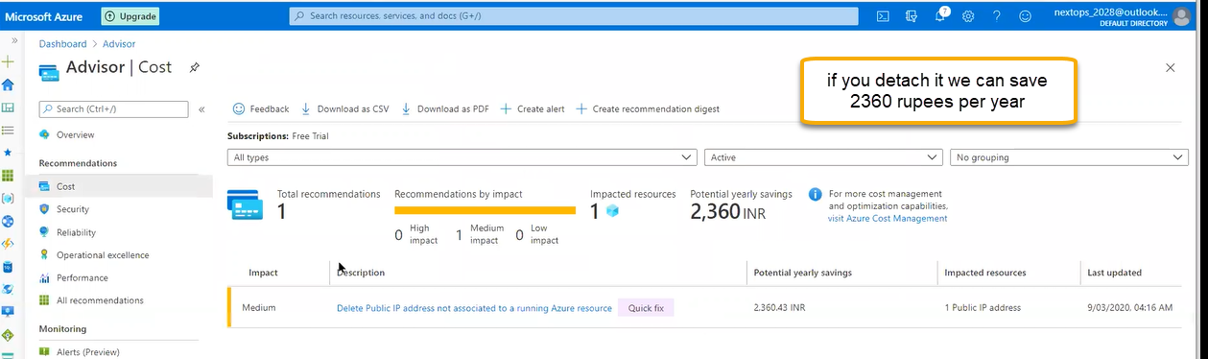

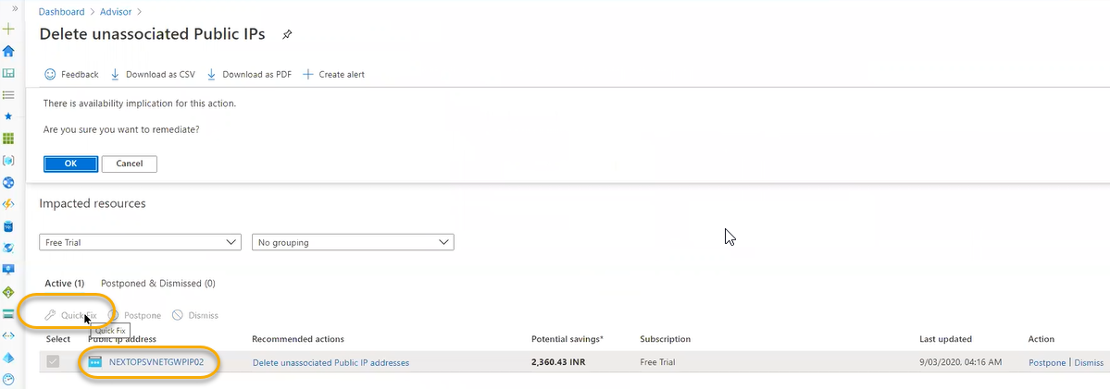

Advisor recommendations and security will help us organization to place in a better shape

Extensions

Extensions are plugins. To take the traditional functionality inside the VM we will install the plugins

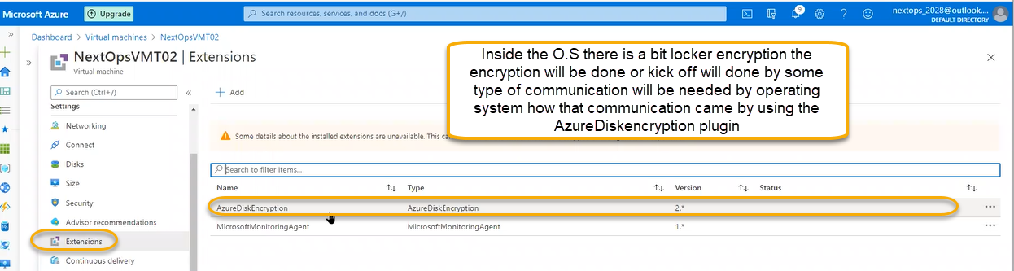

If you enable the AzureDiskencrytion the plugin related to disk encryption will be added here. We can add extensions by clicking on the above + Add button

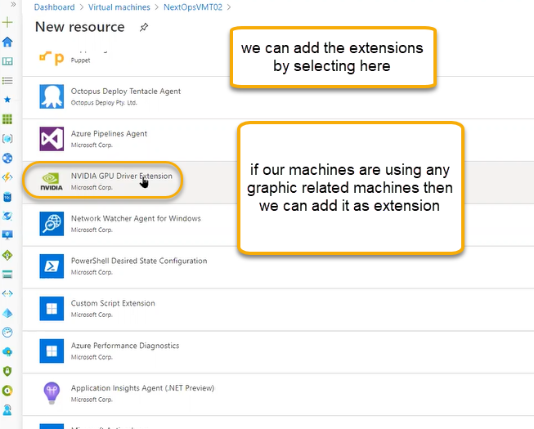

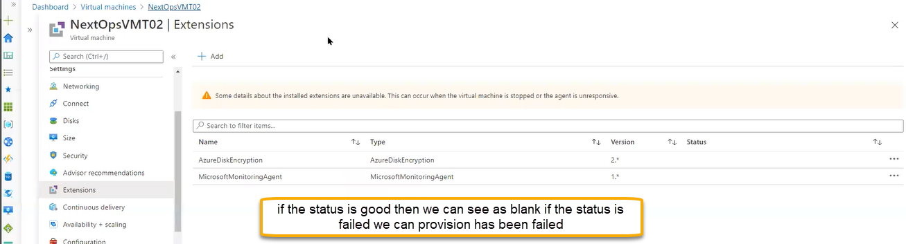

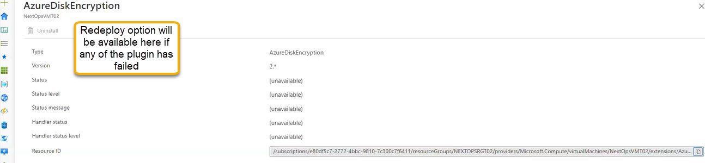

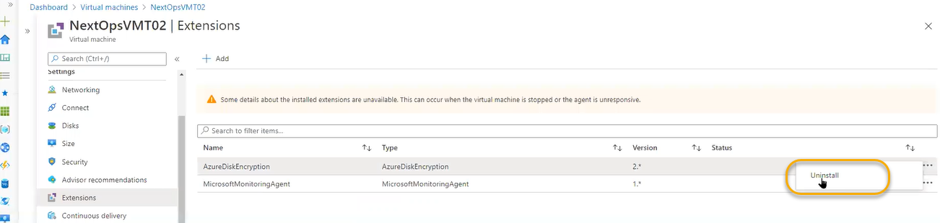

If you are enabling the extensions the machine should be power on mode or running mode

Logs can be seen below location

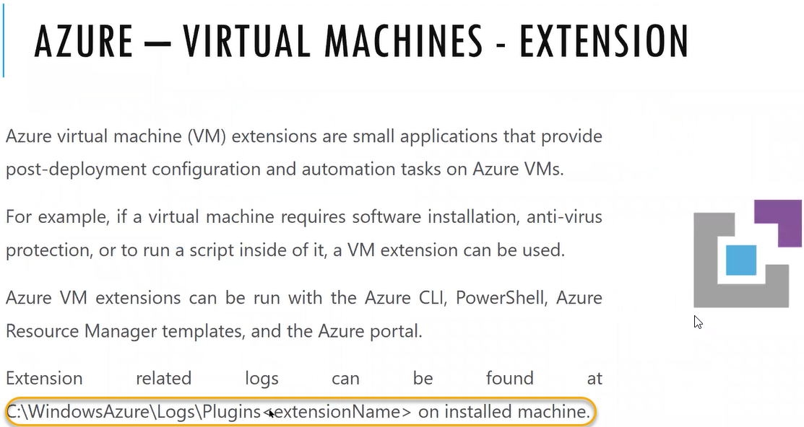

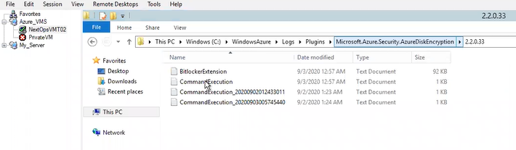

Continuous delivery :IAS or Tomcat we need to install or installation upside we need to place any webapp from azure devops through pipeline has to be created automation.

Availability + scaling

If you place any VM in availability set during the deployment time and if you want to remove that VM from deployment set then we don’t have option. We must recreate it

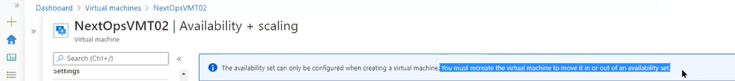

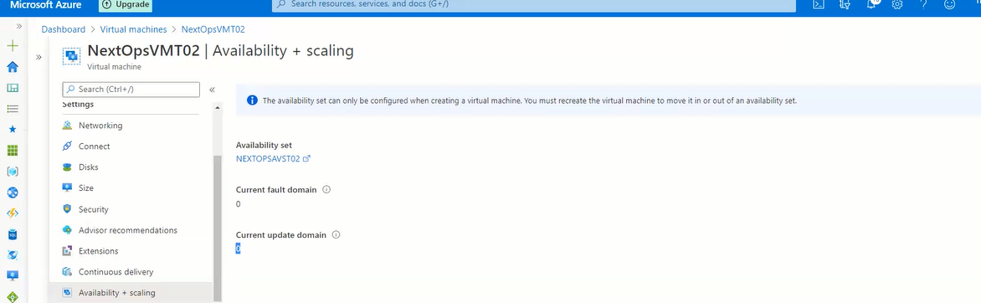

Configuration

If we have already azure hybrid license we enable the Yes option and if you tick this option

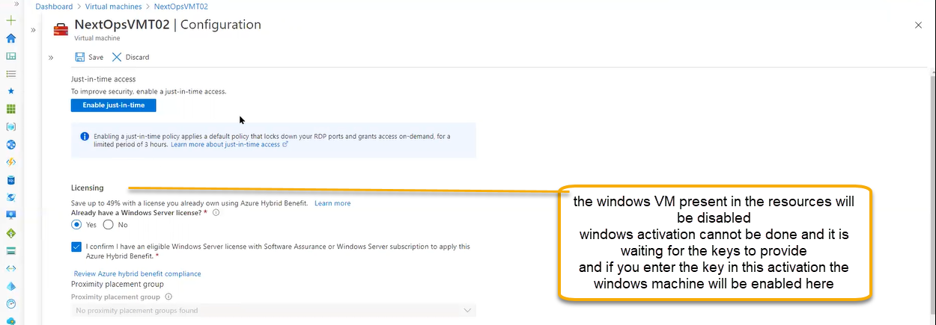

To see the key we need to go This PC > Properties

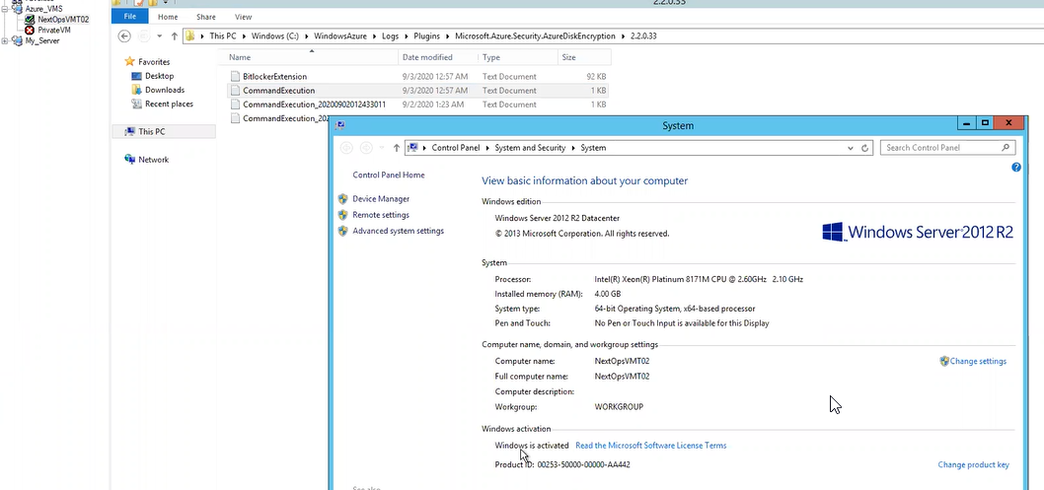

If you have a product key from company sidewe can change here or enter here by clicking the change product key

Activation related issues: Activation cannot connect to server due to firewall block , Invalid key : product key is not compactable if windows 10 product key is used in windows 22 key it will show invalid key

Keys related team will give the genuine keys

Proximity placement group is opposite to availability set

Availability set will distribute the VM in the racks and server and the distance will be maintained so that if any physical will down another will run it will not impact

Due to distance between one rack to another we may experience performance related issues

Latency related issues may come

For some of the applications closeness is necessity they cannot accept the latency related issues

For that we need to configure the Proximity placement group

VM will be placed as close as possible. With in the radius VMs are placed it’s a logical object

Proximity placement group is like a tag

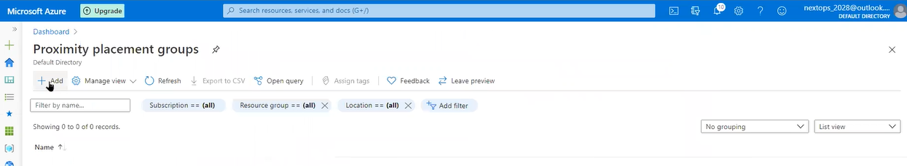

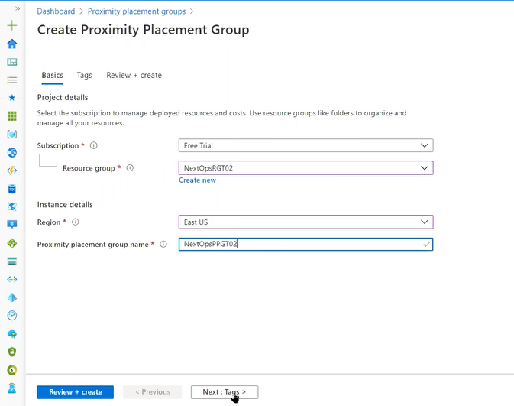

Click next and create

If client need high available, then we need to select the high availability set if need high performance then we need to select the proximity placement group

Host

We are creating VM, storage in azure infrastructure in data centers operations each and activity we are doing will be doing in shared infrastructure. The VM running in underline does not dedicated to ourself in the same server another/other customer VM may run

If you want dedicated infrastructure, then we can assign in the Host or reserve in the host

If you take dedicated host complete physical server will be ours, they will not share to any one

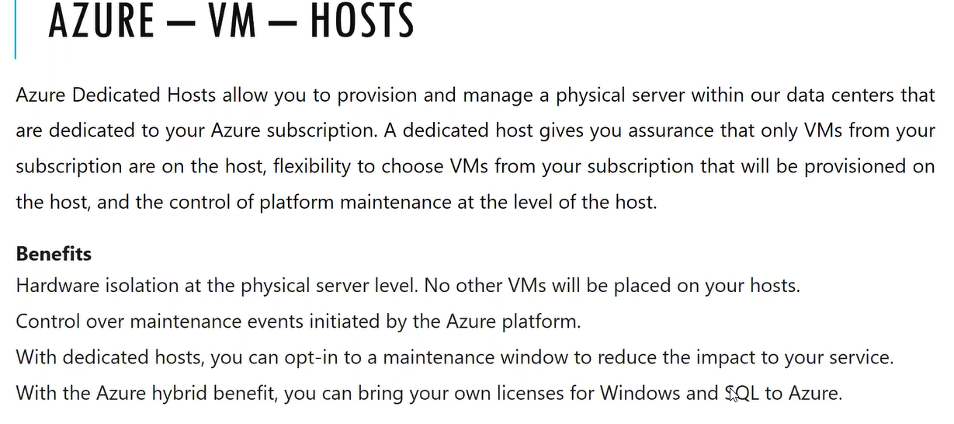

In the scenario we can skip/post pone maintenance upto 35 days

We need to create the host group that is logical object after creation we need to place in the VM

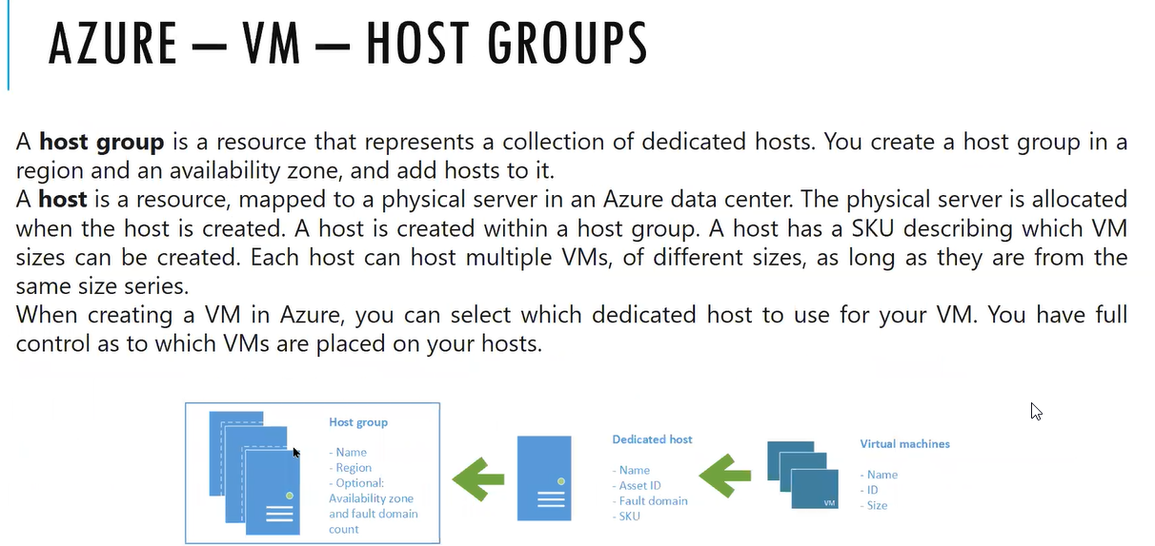

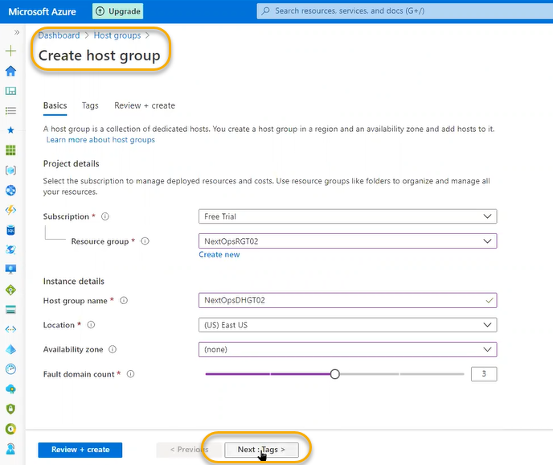

Click next and create it

Physical level fault domain max is 3 where as in host we can extend upto 5

Inside the host group we need to add the host

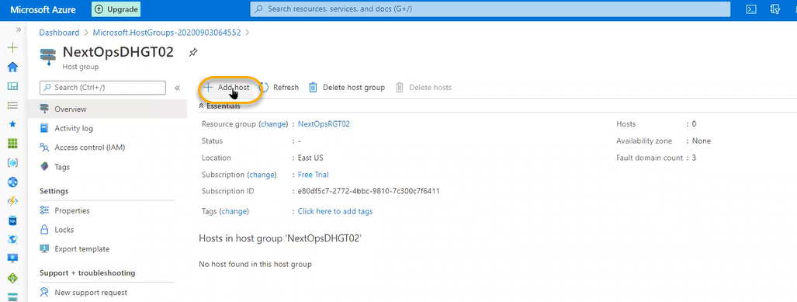

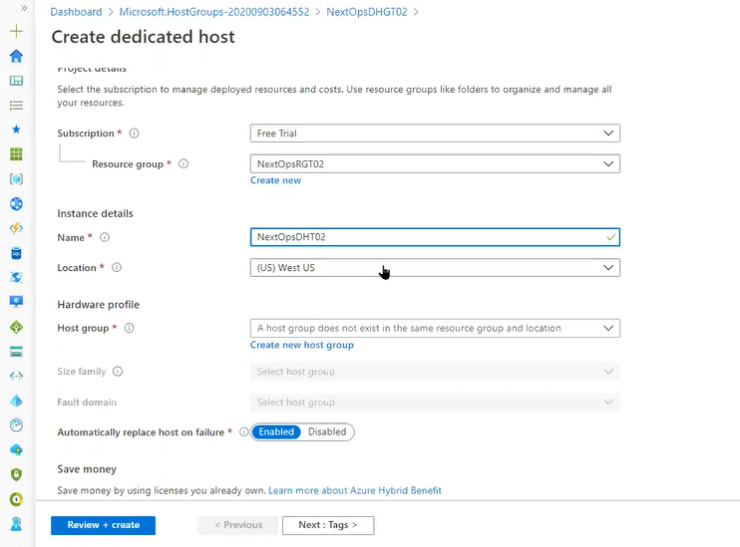

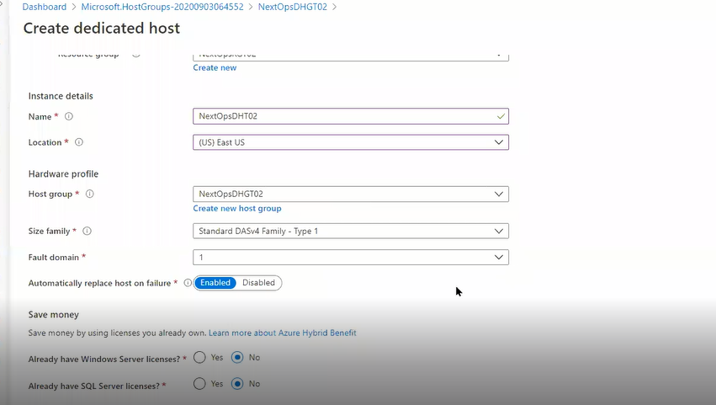

For Size Family we need to search on google to know the exact sizes

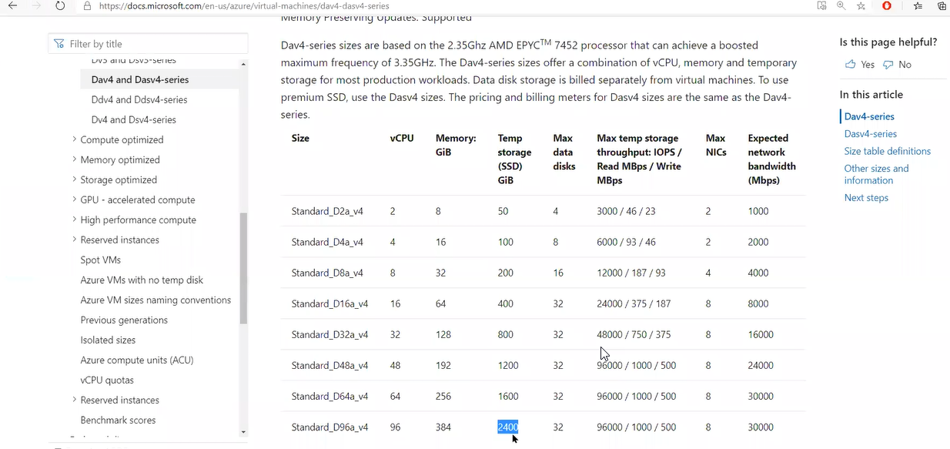

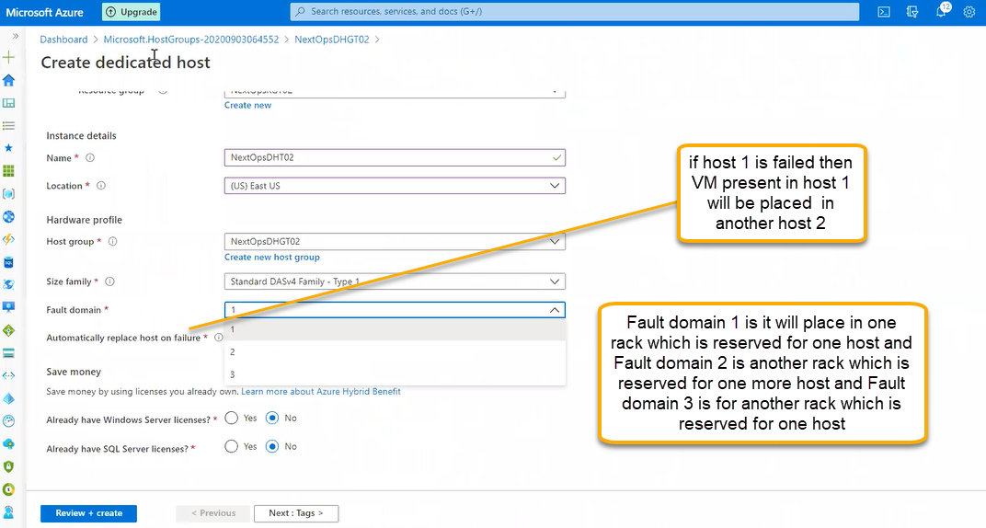

Automatically replace host on failure: if you enable the option and if the host 1 is failed then the VM present in host 1 will be moved to host 2

It will cost you only for the host or physical server not for the VM

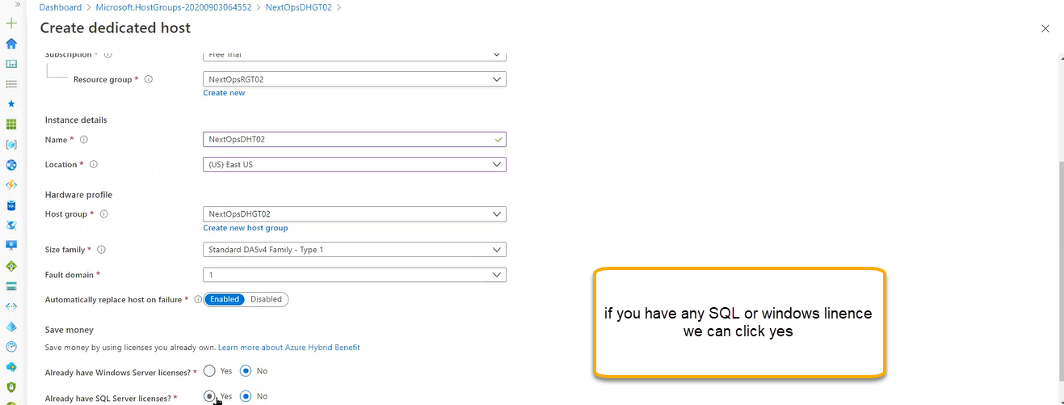

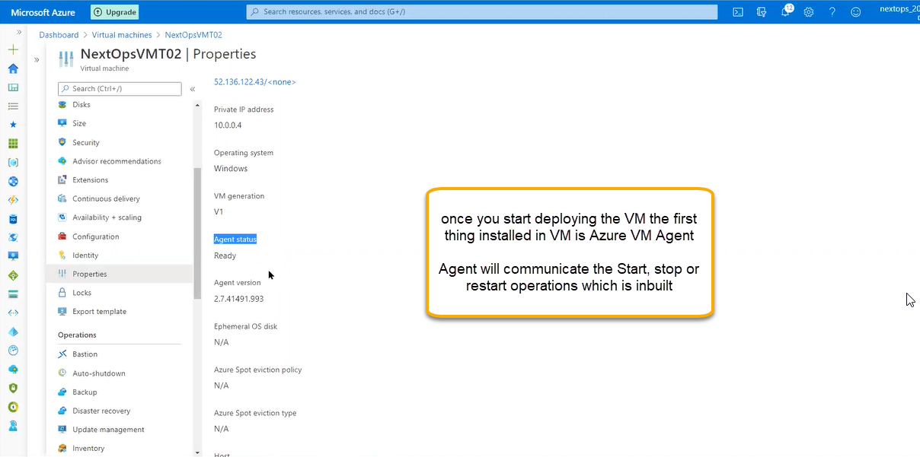

And we see the same in the overview page about the agent as shown below

